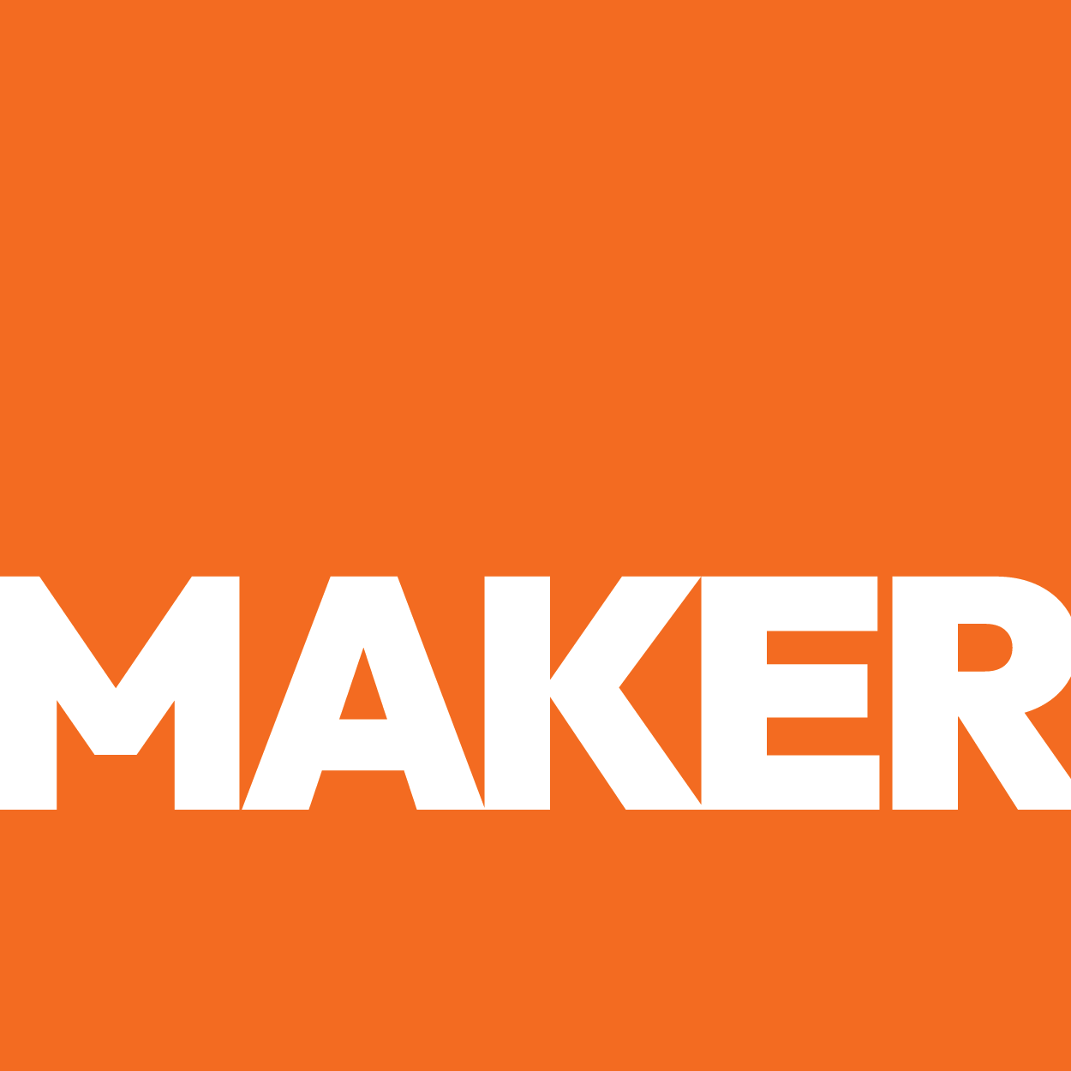

BLIND SPOT AUDIT
BLIND SPOT
AUDIT

[Client Name] — The Strategic Gaps a [Industry] Cannot Afford
● Deep Research Audit ● [Month Year] ● Prepared by Maker Web Studios
CONFIDENTIAL — PREPARED EXCLUSIVELY FOR [CLIENT NAME]
OVERVIEW
What Is a Blind Spot Audit?
A Blind Spot Audit goes deeper than SEO checklists. It identifies the strategic, behavioral, and market-positioning gaps that cost a company leads, loyalty, and long-term market share — the things that don't show up in a standard audit but compound in painful and preventable ways.
"[Opening strategic framing — why the communication gap is the core problem, not the product or service.]"
— Maker Web Studios Audit Finding
OVERVIEW
The 5 Biggest Blind Spots
These are not website fixes. These are business-level strategic gaps with compounding revenue consequences.
01 [Blind Spot #1 Title]
Value proposition blind spot · Critical Revenue Risk · High SEO Impact
THE BLIND SPOT
[Describe the blind spot — what specific credential or advantage is being hidden or communicated generically. What is it costing in lost leads. Why does it persist. Be specific about the competitor winning because of this gap.]
THE FIX
- [Fix 1-1]
- [Fix 1-2]
- [Fix 1-3]
- [Fix 1-4]

02 [Blind Spot #2 Title]
Audience education blind spot · High Revenue Risk · High SEO Impact
THE BLIND SPOT
[Describe what buyer questions are going unanswered — the exact research queries, the decision-stage content missing, and which competitor is capturing those buyers instead.]
THE FIX
- [Fix 2-1]
- [Fix 2-2]
- [Fix 2-3]
- [Fix 2-4]

03 [Blind Spot #3 Title]
Distribution blind spot · High Long-Term Risk · High Channel Impact
THE BLIND SPOT
[Describe which digital channels the buyer uses before they ever call — and which ones the client is completely absent from. Be specific about directories, platforms, and search behavior.]
THE FIX
- [Fix 3-1]
- [Fix 3-2]
- [Fix 3-3]
- [Fix 3-4]

04 [Blind Spot #4 Title]
Conversion blind spot · High Conversion Risk · Low Fix Complexity
THE BLIND SPOT
[Describe the friction points in the buyer experience — phone number placement, CTA language, RFQ form absence, live chat gap. Describe what the current experience communicates vs. what it should.]
THE FIX
- [Fix 4-1]
- [Fix 4-2]
- [Fix 4-3]
- [Fix 4-4]

05 [Blind Spot #5 Title]
Brand trust blind spot · High Trust Risk · Low Fix Complexity
THE BLIND SPOT
[Describe how the company's single most powerful differentiator is buried in body text instead of leading the page. What does a 30-second visitor see vs. what they should see?]
THE FIX
- [Fix 5-1]
- [Fix 5-2]
- [Fix 5-3]
- [Fix 5-4]

OVERVIEW
Strategic Opportunity
[Write 2–3 paragraphs: what the client has earned through operational execution, why these blind spots are communication problems not product problems, and what becomes possible when they are closed.]

"[Closing quote — what becomes possible when the operational excellence matches the digital presence.]"
— Maker Web Studios Audit Finding

